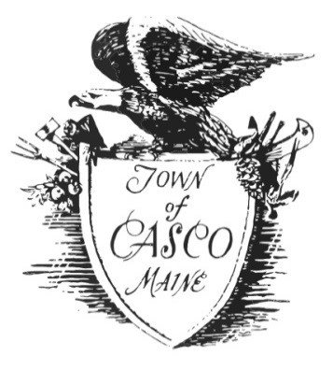 | Town of Casco
 | Selectboard Regular Meeting Agenda
 | July 25, 2023 at 6:00 PM
Casco Community Center
Amended 07-20-2023
Regular Meeting
1. Review and approval of the meeting agenda
2. Approval of bills and signing and approval of all open warrants
3. Approval of Minutes: July 11, 2022
4. Public Participation for non-Agenda items
5. Manager’s Update
Old Business
6. The Selectboard will consider a policy relating to Bulky Waste Coupons
7. The Selectboard will discuss the status of the Comprehensive Plan
New Business
8. The Selectboard will consider the liquor license renewal of Migis Lodge
9. The Selectboard will consider the Waste Motor Oil Disposal Remediation funds (a/k/a Tenney Hill Waste Oil Fund)
10. The Selectboard will discuss the Septic System Replacement Program
11. The Selectboard will consider contracting General Assistance services to Cumberland County
12. The Selectboard will consider a lease purchase agreement with Androscoggin Bank for the John Deere backhoe
13. The Selectboard will consider making August 8, 2023 as a workshop to tour Point Sebago and Club Sebago Association properties
14. The Selectboard will discuss employee work hours
15. The Selectboard will consider MMA Annual Election
16. Discuss Casco Naples Transfer Station Council meeting scheduled for August 3, 2023
17. The Selectboard will consider a Settlement Agreement with Hello Doggie Daycare and Migis Lodge, LLC.
18. The Selectboard will discuss speed bumps on Mayberry Hill Road by Please Lake Beach
19. The selectboard will consider three (3) quotes for 1-ton truck and gear
Executive Session
20. Executive Session to discuss Concealed Weapon Permits per Title 25, Part 5, Chapter 252, Section 2006 for applications 07/25/2023A & 07/25/2023B
21. Adjournment
Reminders to the Attending Public: Selectboard meetings are open to the public, but the public may not speak unless recognized by the Board Chair or Vice Chair in their absence. Except during a public hearing, comment time is limited to 2 minutes per speaker during public participation or on agenda items. Matters related to personnel will not be heard.

Future meeting dates (subject to change)
August 3, 2023 @ 6:00 pm Casco/Naples Transfer Station Council
August 8, 2023 @ 6:00 pm Selectboard Workshop
August 8, 2023 @ 6:00 pm Comp Plan Steering Committee
August 14, 2023 @ 6:30 pm Planning Board Regular Meeting
August 21, 2023 @ 6:00 pm Open Space Commission
August 22, 2023 @ 6:00 pm Selectboard Regular Meeting

