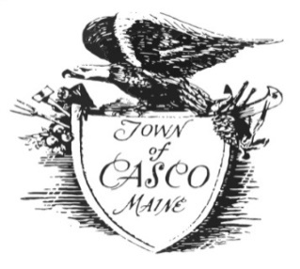

Casco Zoning Board
July 18, 2022
6:30 P.M.
Community Center Meeting Room

First Order of Business:

- Organize Board (Chair) and (Vice Chair) for new

- Call Meeting to Order

- Determine a Quorum

New Business:

- Variance Appeal, Property Owner Kirt Bell, Map 18, Lot 2. Lakewood Road.
Re-Applying After Approval on May 20, 2022 and Registered with the Cumberland County of Deeds.
Permit Lapsed and Cannot be Extended Per Town Code and Towns Attorney, without New Submittal to Zoning Board of Appeals

Additions:
- None

Next Meeting:

- August 15, 2022 if Needed

Adjourn

