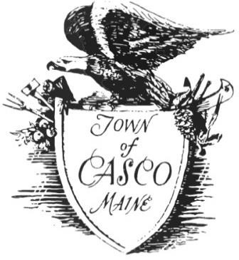
TOWN OF CASCO
PLANNING BOARD MINUTES
MAY 11, 2022

Planning Board Members Present: Ryan McAllister, (Chair), Stan Buchanan, (Vice), Peter Watkins, Marc Rocque, Kendra Osborne

Planning Board Members Absent:

Staff Present: John Wiesemann, Mary Tremblay

Public Present: Aaron Osborne

First Order of Business:

The Chair called the meeting to order at 6:30 pm

The Chair determined a Quorum with five members present

Approval of the May 2, 2022 Meeting Minutes

Kendra moved to approve the May 2, 2022 meeting minutes as written
Stan seconded the motion
The Board voted 5-0 in favor, the motion passes

Old Business:

1. Withdrawal of the Moratorium on Commercial Solar Farms Motion Made May 2, 2022 at the Planning Board Meeting

Ryan noted as discussed with the Town Manager, it is not the authority of the Planning Board to propose a moratorium. It needs to following the criteria of an ordinance and be presented as a public hearing and be voted on. The Board was asked to rescind the motion.

Marc moved to rescind the motion to propose a moratorium on large solar projects
Stan seconded the motion
The board voted 5-0 in favor. The motion passes

2. Final Discussion, Decision and Recommendation to the Selectboard regarding Marijuana Ordinance, STR Ordinance and Water Extraction Ordinance for the Annual June Town Meeting

Ryan asked for discussion or concerns

Peter asked if it there was any headway made with the water extraction, as to what bodies of water, a limit you can take and if it is just for industrial commercial.

Ryan noted it is his understanding right now would be to take the ordinances as written since there is not enough time to change them and have them ready for town meeting. It was suggestion to get them established now, and if the Board feels comfortable with the ordinances as a starting point, they can be amended as needed down the road.

Kendra noted there are definitely concerns with all the ordinances which the board had discussed, however in order to have something in place before the town meeting, it’s important to approve what there is since there is not enough time to make any changes. It can always be amended at a later point if needed.

Ryan agreed it gives the Board a starting point, although they may not be perfect it gives the board something to use and go by, having the chance to amend down the road.

Stan noted they are good to go. The CEO has done a good job researching them with other towns and adjusting them to make them work.

Ryan noted it would give the board something to start with. He noted he is not sure and concerned about the enforcement expectation and lack of support for the CEO

Marc stated the public at the hearings brought some of the concerns forward and the board made note of them.

Stan noted what we have in place is a good starting point.

Stan moved to recommend the ordinances to the Selectboard
Peter seconded the motion
The Board voted 5-0 in favor. The motion passes

Additions:

John presented the latest revision approved Plan layout of the Hancock Old Mill Farms for signing by the Board

The Board Signed the Plans

John presented a copy of the Denmark Solar Ordinance to the Board for review. He noted a lot of time went into it and maybe a workshop night would be good to go over some other

Ryan noted he liked the suggestion to do a workshop night and coming up with ideas on the solar ordinance and maybe at the same time the new ordinances once the board sees how it went at town meeting.

The Work Shop date was set for June 22, 2022 at 6:30 pm

John also noted he had a call come in questioning if the town had any in town Energy Storage places and if not, would the town allow it. Therefore, this might be something coming down the pike and for the Board to keep in mind.

Stan asked if there could be someone representing the State at the solar workshop meetings.

John stated he might be able to get someone. He will look into it.

Adjourn:

Kendra moved to adjourn the meeting at 7:00 pm
Stan seconded the motion
The Board voted 5-0 in favor. The motion passes.

